Hélio Ferreira 22/05/2024

# **Lab: DLP and Classification**

### **Part 1: Staging**

For this lab you’ll need a trial license for Trend Micro’s endpoint security agent software.

* Register for an account at [Trend Micro Worry-Free Business Security Services 30-Day Trial](https://www.trendmicro.com/product_trials/service/index/us/136).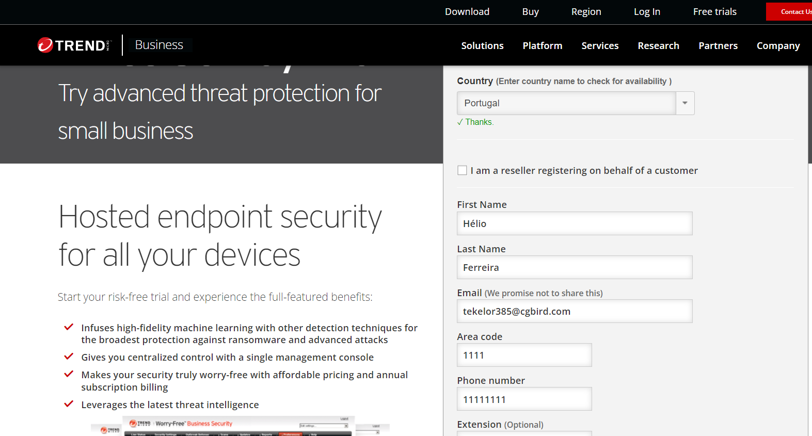
* From the PC or VM you’re installing agent to, access the portal and download the agent. The type of computer used should not affect the lab but Windows 10 is generally recommended.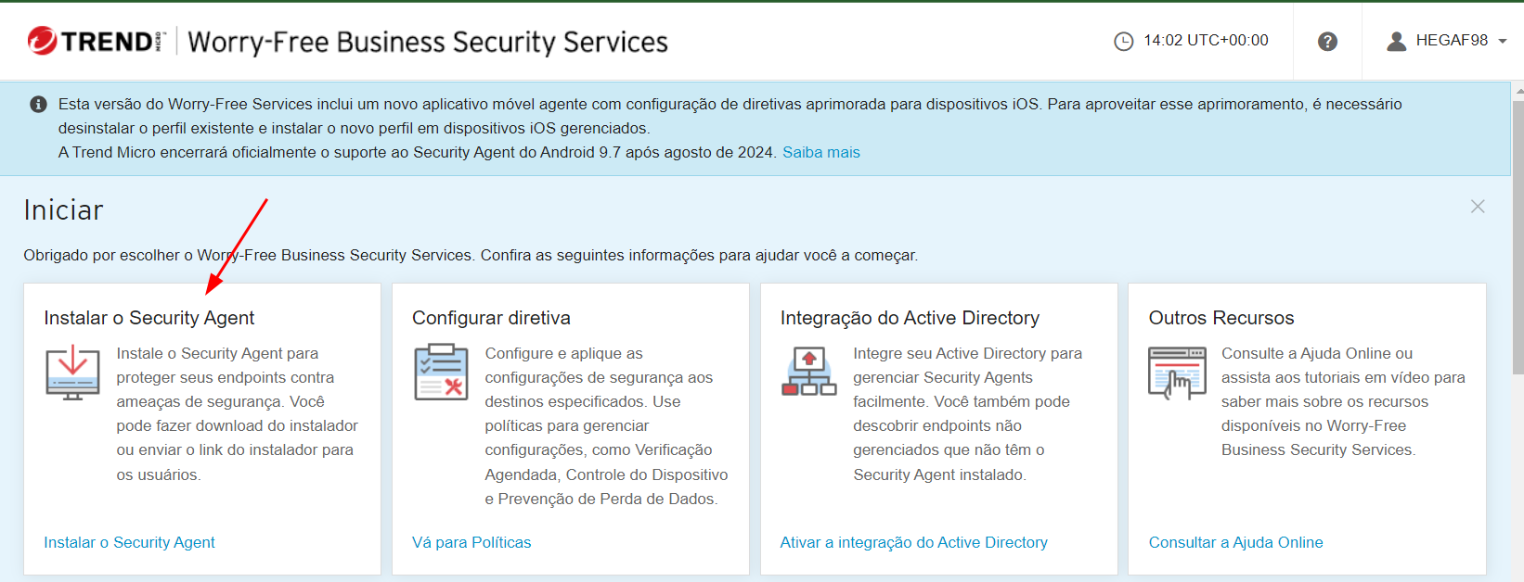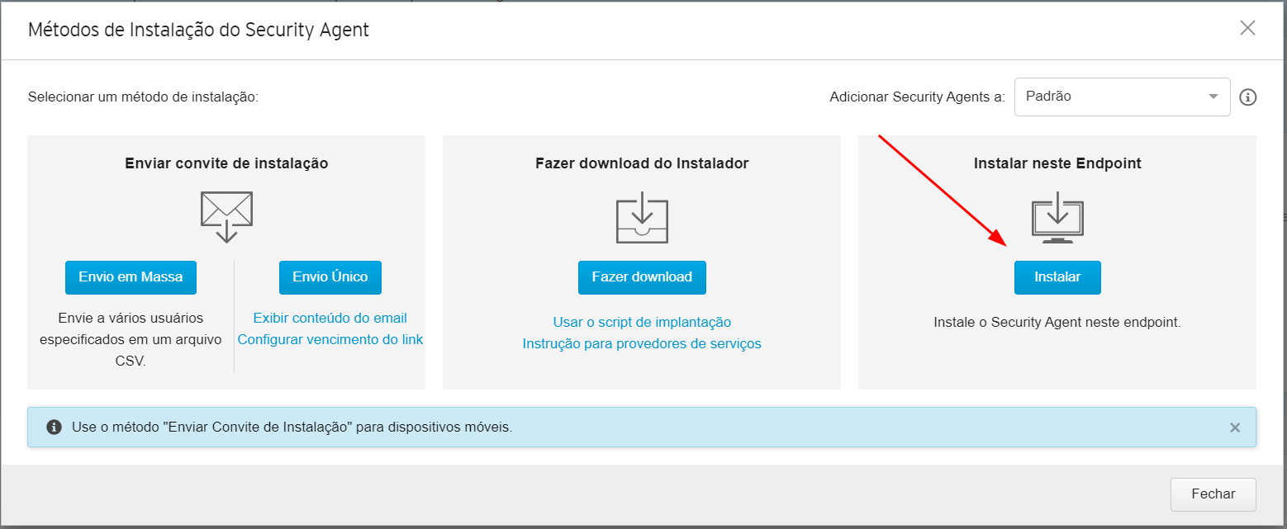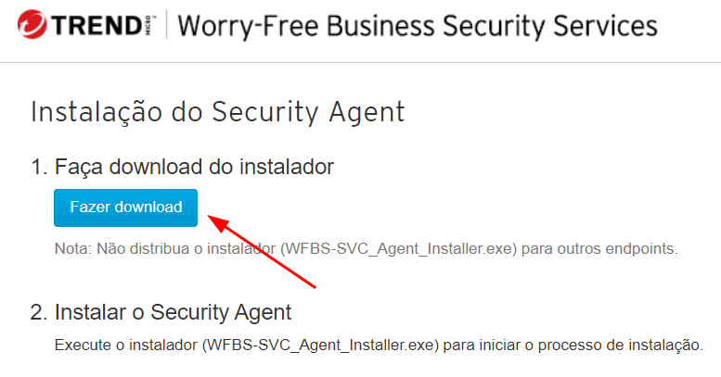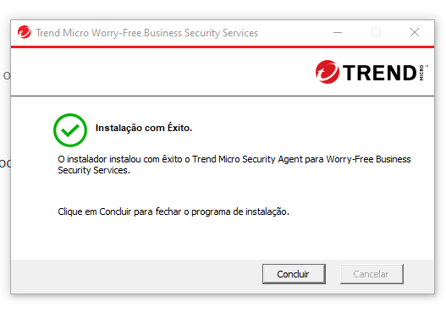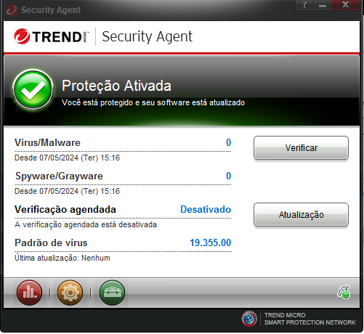

### **Part 2: Baseline Evaluation**

On [DLP Test](https://dlptest.com/) perform the following tests to establish a baseline configuration:

* HTTP POST
  + Test one sample SSN or CCN file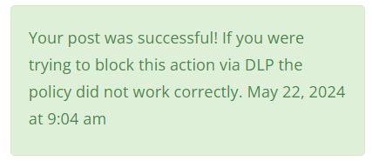
* HTTPS POST
  + Test one sample SSN or CCN file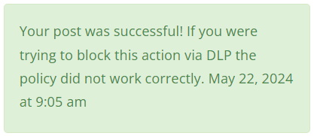
* FTP Test using FileZilla
  + Test all sample SSN and CCN files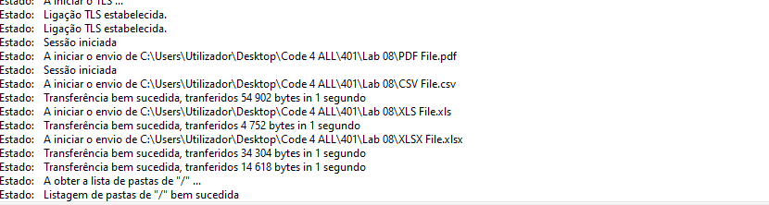

For these tests, use the provided [sample data](https://dlptest.com/sample-data/). Note in your reporting for today the baseline condition of this system.

*Note: For the FTP Test you will have to install FileZilla to your Win10 VM and connect to the dlptest.com FTP server using the information found on the FTP Test page. Follow the instruction on the article provided in the References section.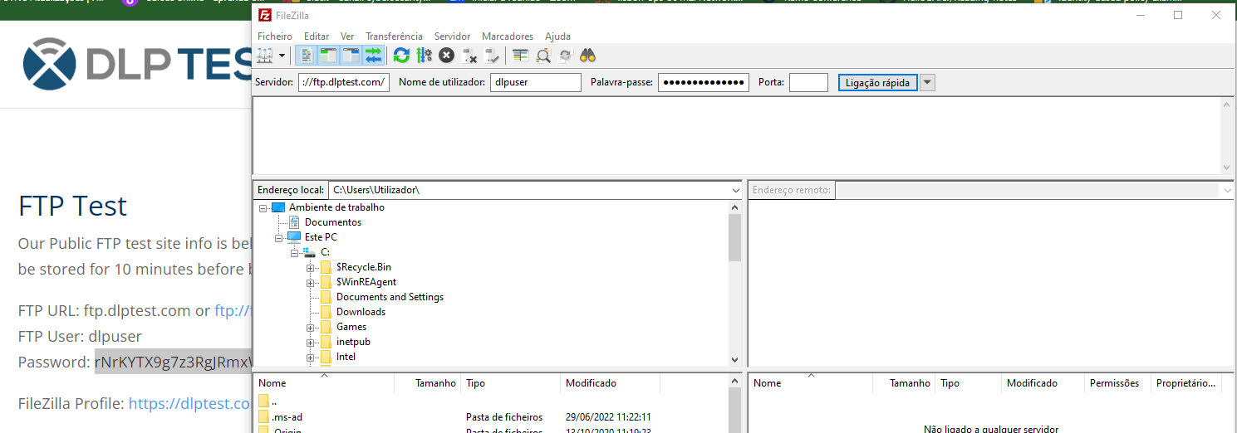*

The data types to test today include:

* Social Security Number (SSN)
* Credit Card Number (CCN)
* Date of Birth (DoB)

### **Part 3: Endpoint DLP Policy Implementation with Trend Micro**

The next step will be configuring DLP settings in Trend Micro to match our needs. Today we’re focusing on achieving PCI-DSS compliance, so configure a policy accordingly.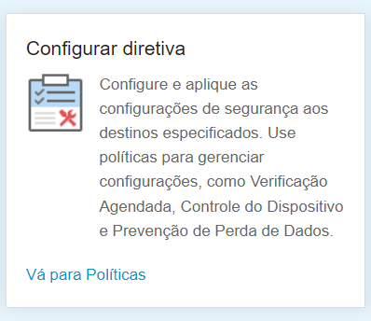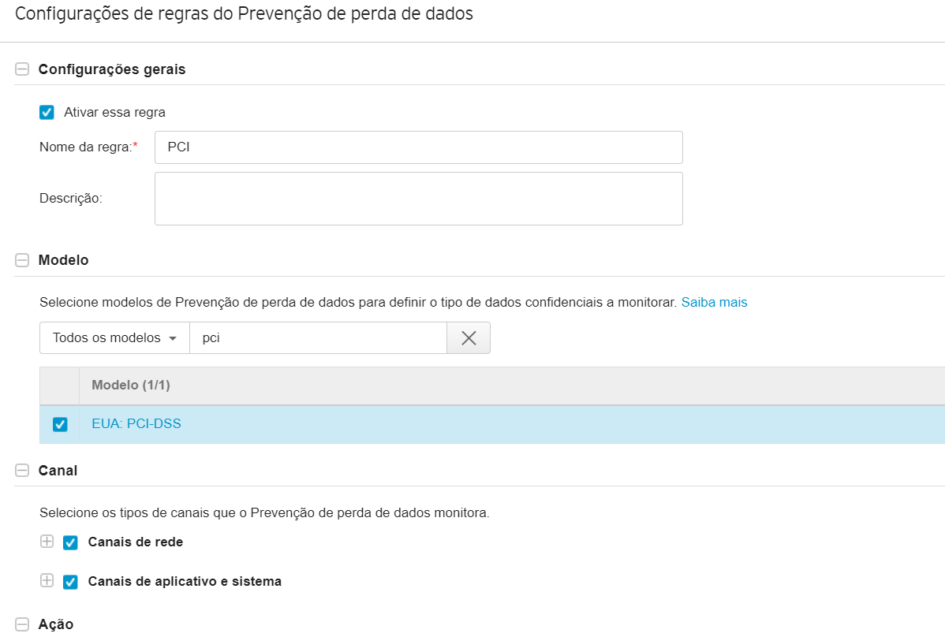

Once your agent is updated with a DLP policy, test its efficacy on [DLP Test](https://dlptest.com/) perform the following tests to establish a baseline configuration:

* HTTP POST
  + Test one sample SSN or CCN file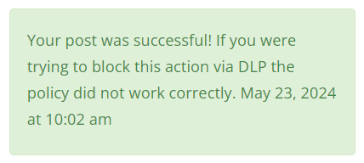
* HTTPS POST
  + Test one sample SSN or CCN file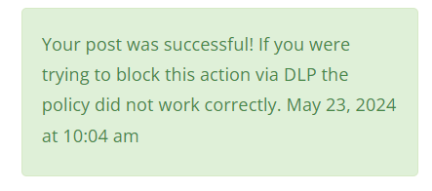
* FTP Test using FileZilla
  + Test all sample SSN and CCN files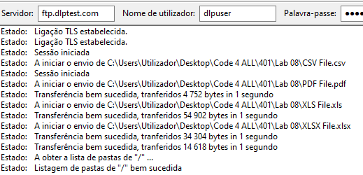

For these tests, use the provided [sample data](https://dlptest.com/sample-data/). Note in your reporting for today the outcomes of this test. If any PII or PCI data failed to be blocked, revisit your DLP policy in the Trend Micro portal and revise configurations as necessary to achieve the target outcome.

The data types to test today include:

* Social Security Number (SSN)
* Credit Card Number (CCN)
* Date of Birth (DoB)